Our Mission: To provide career counseling services through personalized vocational assessment, and evaluation. To promote self-awareness and to identify individuals’ Strengths, Interests, Aptitudes, and help them maximize their full potential.
Vocational Assessment
Counseling

Who are the Vocational Assessment Career Counselors?
The Vocational Assessment Counselors are fully trained professionals who specialize in the field of personal development, education and growth potential.
Who should seek the help of a Vocational Counselor?
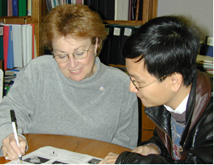
All CalWORKs participants who have limited education and/or work experience, or those who may be uncertain about vocational goals, should seek the assistance of the Vocational and Career Counselor. Individuals who are challenged by a variety of personal and employment barriers such as: physical disabilities, learning difficulties or substance abuse.
What are the assessments tools the Vocational Counselor utilizes to help me?
- Academic Skills  “What would be the best job for me?” | - Interests
- Abilities & Values | - Vocational Skills
- Learning Difficulties | - Self Employment
- Degree Evaluation | - HSD/GED
After my vocational assessment, what are my options?
Once your vocational assessment is completed, the Counselor will present you with the most viable options to reach your goals and ensure your success. Some of the options may include: Vocational Education, Employment Training, Career Exploration, and/or further vocational counseling.

How do I sign up to receive these services?

There are several ways to sign up for these services:
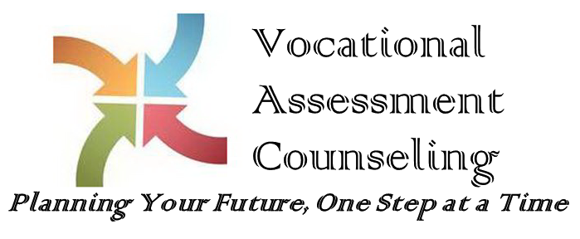
- Contact your case worker, or
- If you are participating in a Welfare to Work
activity (Job Club, Job Search, CWEX, Life Skills),
please let your facilitator know, or
- Call (916) 875-3330 and ask for a VAC Supervisor

